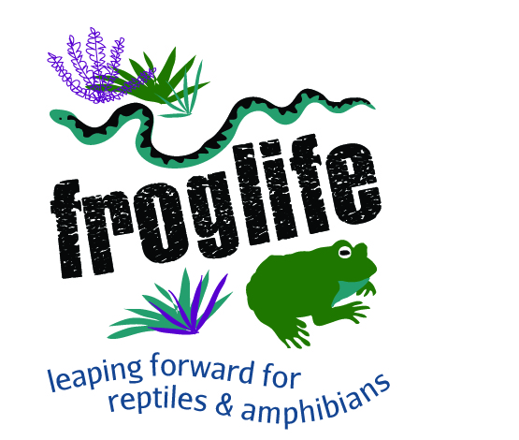
Toads on Roads (Amphibian Crossings) Site Registration Form
Please complete both pages of the form and send to: toads@froglife.org or post
to Froglife, 1 Loxley, Werrington, Peterborough, PE4 5BW
Site Details |  |  |  |  |  |  |  | Person Registering Site
REGION |  |  |  |  |  |  |  | YOUR CONTACT DETAILS
COUNTY |  |  |  |  |  |  |  | NAME
SITE NAME |  |  |  |  |  |  |  | ADDRESS
ROAD NAME/S
POST CODE |  |  |  |  |  |  |  | TEL
GRID REF. |  |  |  |  |  |  |  | EMAIL
Are you willing to be a contact for the site?

Are you going to organise a Toad patrol? (Please fill in Page 3)
SPECIES PRESENT – tick if present
 | Frog |  |  |  |  |  |  |  | Palmate Newt
 | Toad |  |  |  |  |  |  |  | Great Crested Newt
 | Smooth / Common Newt |  |  |  |  |  |  |  | Other – please specify
Amphibian Data – Please estimate if you do not have exact figures

Year
(Please complete for all years where you hold data)
Total no. of Toads saved
Total no. of toads killed
Number of volunteers involved (Average per night patrolling)
Numbers of other amphibians saved (species and numbers)

MAP OF SITE – Please create a map of the site - a hand sketch or copy and paste google maps etc, to show the extent of toad migration routes across the roads. Please indicate breeding ponds if known. Any notes on the extent or character of the crossing would be appreciated.

Patrol Manager Registration form
Date……………………………….
Name ………………………………………………………………………………………………

Email………………………………………………………………………………………….….
I am volunteering to be a contact regarding the site,  but not to manage patrols | Y/N
I am volunteering to manage patrols for the above crossings  Please make sure you read the patrol pack,  http://www.froglife.org/what-we-do/how-to-become-a-toad-patroller/  before ticking below | Y/N
I confirm that, when undertaking activities on behalf of Froglife,  I will do so in accordance with the procedures contained in the Toads  on Roads Patrol Pack. | Please  tick or initial
I have read and understood the Health and Safety information contained in
the Froglife Toads on Roads Patrol Pack

I understand the risks associated with Toad Patrolling and have visited the site and undertaken a full Risk Assessment accordingly

Or if taking over a functioning patrol, I have checked and countersigned the original Risk Assessment.

The information you have given us will be stored on a computer database at Froglife, but will not be shared with anyone else without your permission.

Froglife often receive enquiries from people interested in volunteering with a ‘Toad Patrol’ or local media enquiries (please tick for yes). We will not give your details on to any other third parties.

- Yes, I am happy for Froglife to pass on my contact details (see below) directly to potential volunteers & journalists
- Email address
- Landline Phone number
- Mobile number
Thank you

