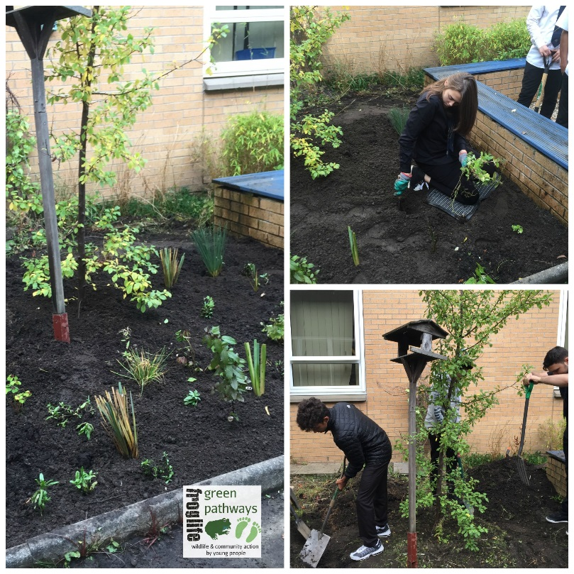
Photo collage (left):
Cleveden High School, S5.
John Muir group, digging and planting a new bog garden for their school.
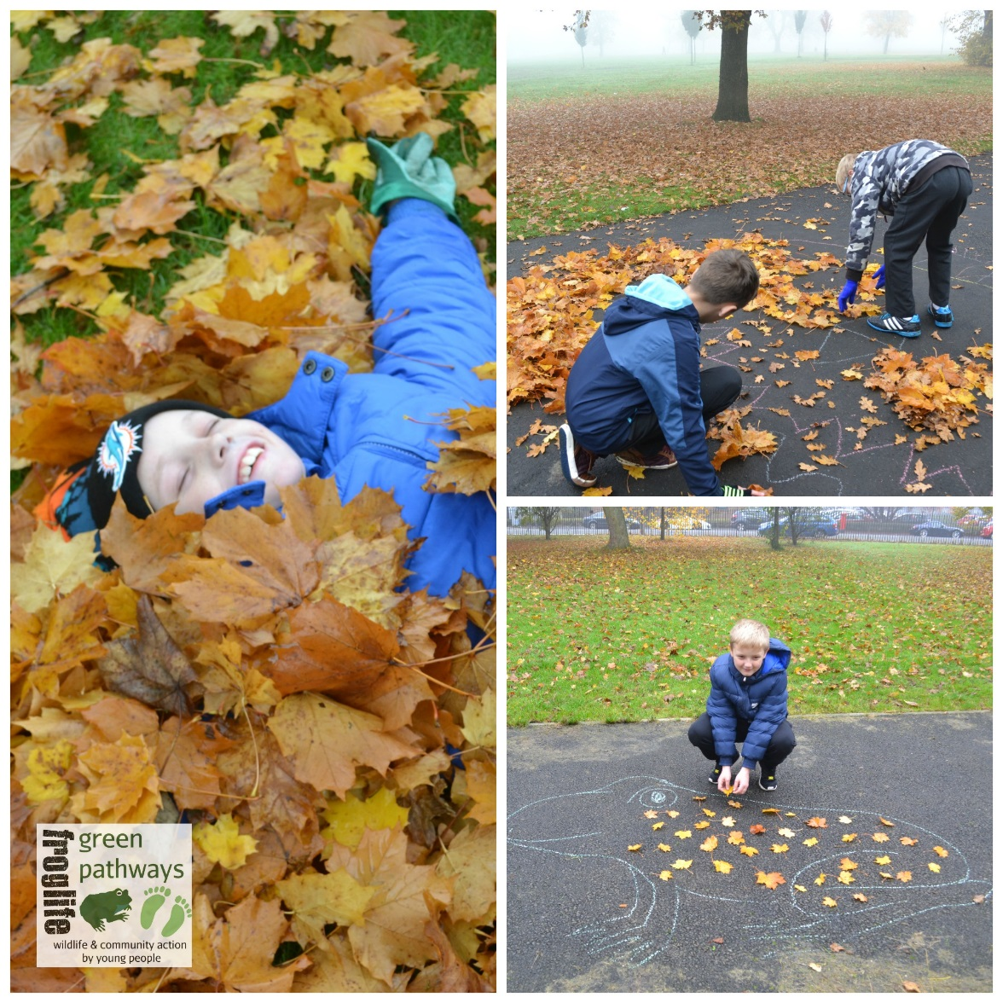
Collage (above):
Pirie Park Primary School, P6 ‘behaviour group’
Environmental art and autumnal delight!

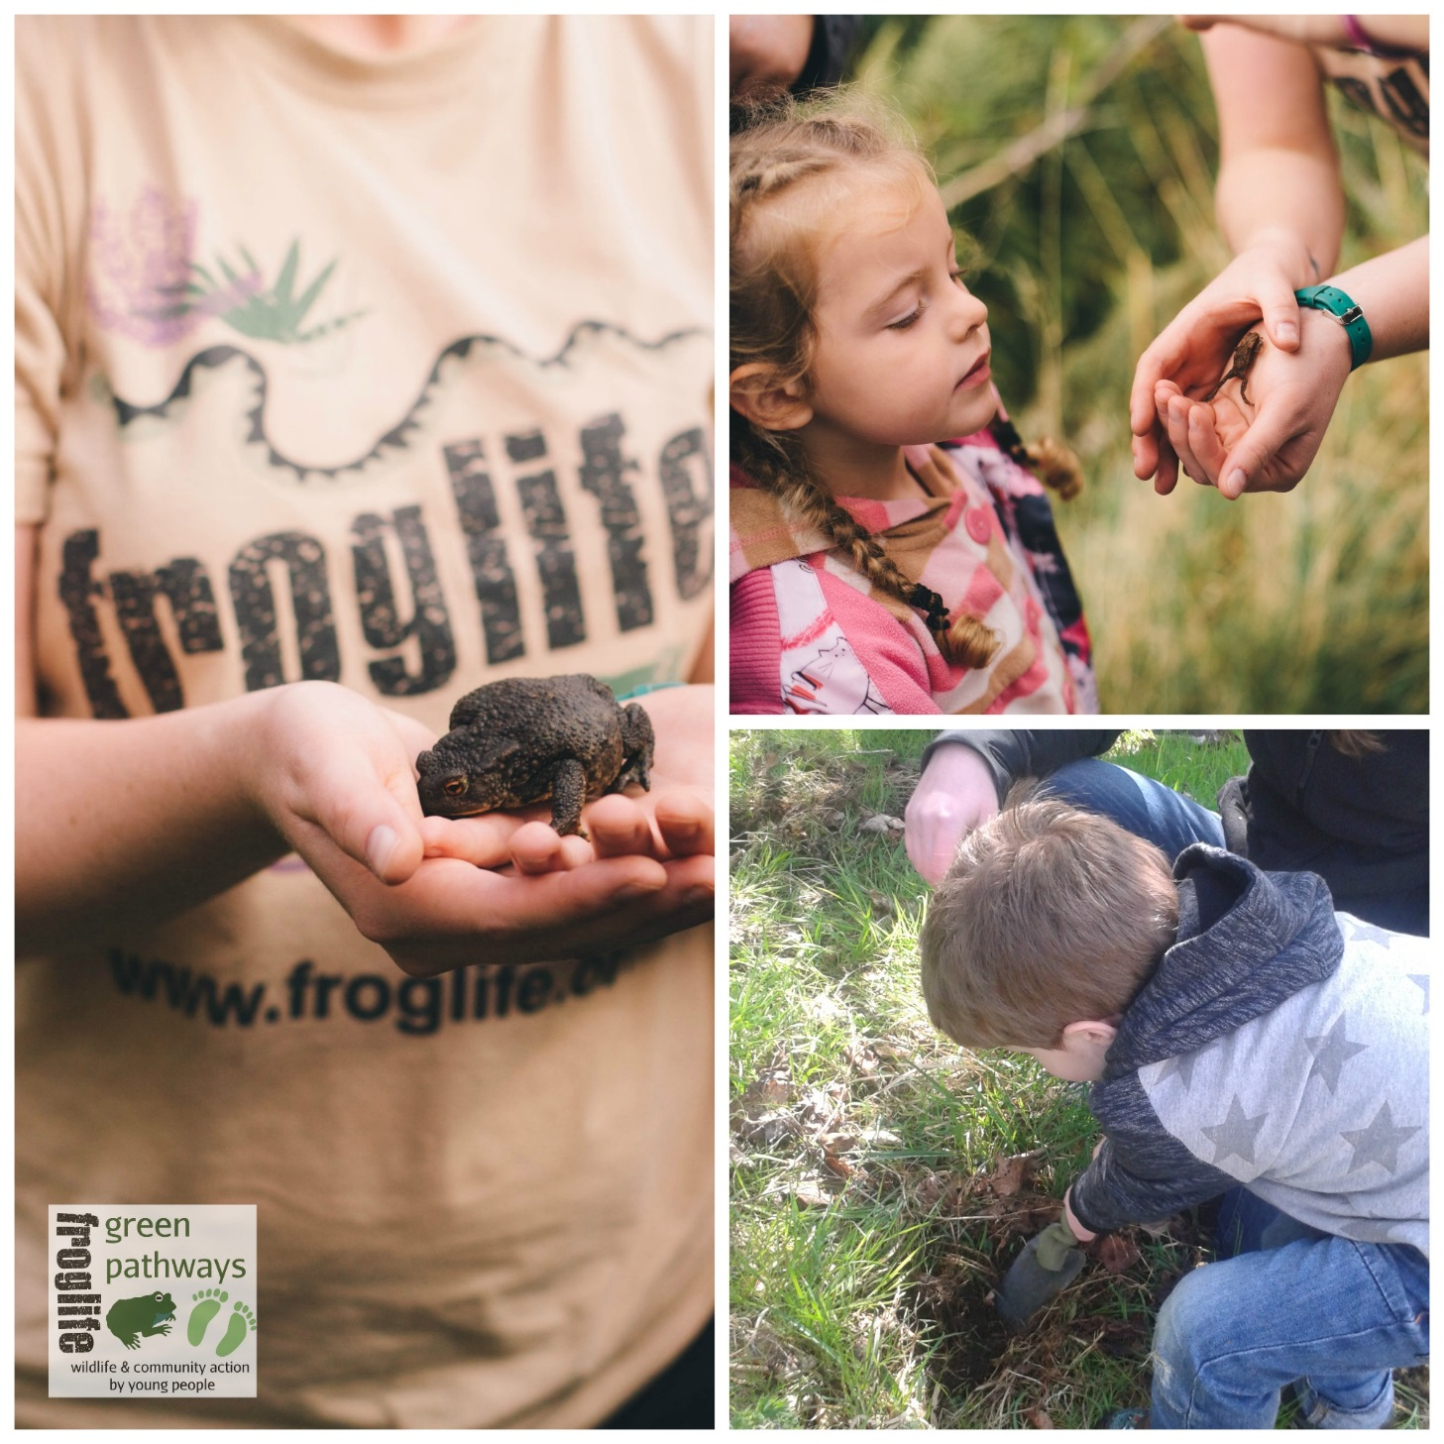
Collage (above):
At the Claypits Local Nature Reserve.
Searching for toads and planting wildflowers with The Green Grovers.

