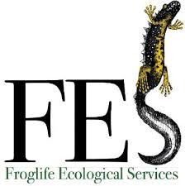

2021 Froglife Training Booking Form
Location
Preferred Date 1
Preferred Date 2
Preferred Date 3
Billing Information
Name
Address
Postcode
Email

Please return to marie.homewood@fles.org.uk (this is for the booking & billing process only, further information will be sent closer to the commencement of the courses)

